Lab 4- Compare Results from Raw Tables vs. a Curated Data Product

Estimated completion time
- 20 minutes

Learning objectives
In this lab, you will compare how customer metrics are calculated using raw source tables versus querying from a curated data product.

The curated dataset, customer_360, combines usage, billing, and CRM data into a single view with pre-calculated metrics such as lifetime_value, avg_usage_last_90_days, and churn_risk_score.

By the end of this lab, you will

- Understand the complexity of working with raw tables.
- Learn how a curated data product simplifies analysis and ensures consistent metrics.
- Use both approaches to answer a key business question: Which customer segments show the highest churn risk?

Prerequisites
- Lab 1: Access Your Lab Environment

Activities
- Explore the raw tables
- Calculate metrics from raw tables
- Query the curated Customer 360 data product
- Query raw tables to answer a business question
- Query a data product to answer a business question

Step 1: Explore the raw tables
- Start by exploring the individual datasets.

-- Raw CRM customers
SELECT *
FROM crm.customers
LIMIT 10;

-- Raw product usage
SELECT *
FROM usage.events
LIMIT 10;

-- Raw subscription revenue
SELECT *
FROM billing.subscriptions
LIMIT 10;

Notice that:
- Usage data contains daily event-level usage hours.
- Billing data contains subscription amounts and renewal dates.
- CRM data contains customer attributes such as segment.

CRM data:
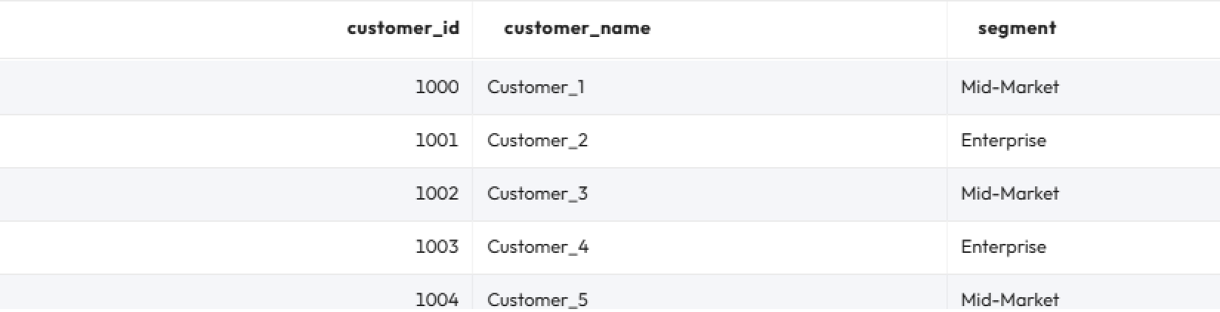

Usage data:
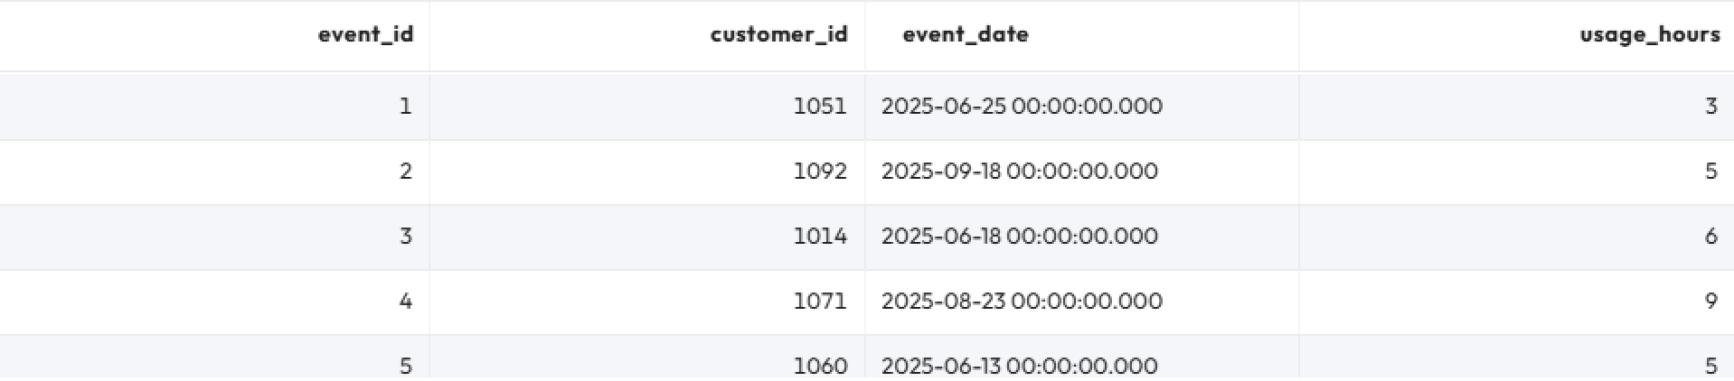

Billing data:
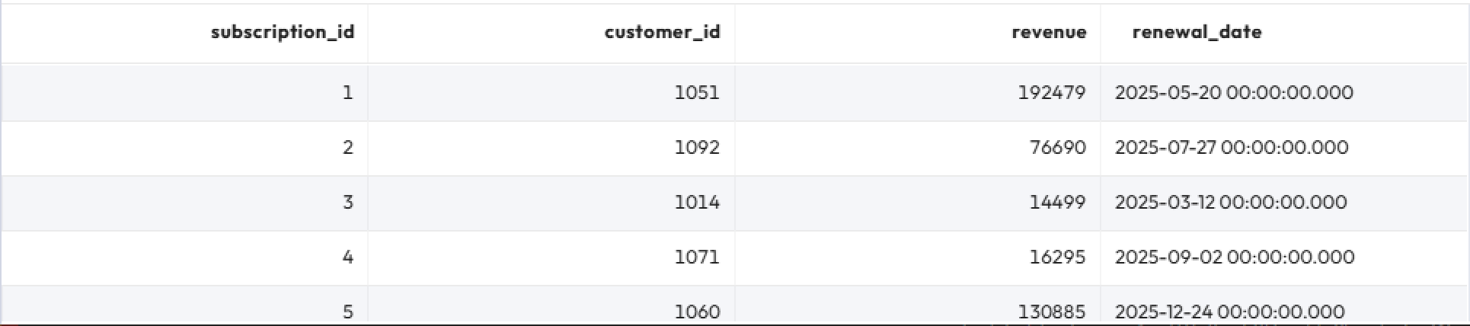

Step 2: Calculate metrics from raw tables
Let’s calculate lifetime_value, avg_usage_last_90_days, and churn_risk_score directly from the raw tables.

SELECT
ev.customer_id,
c.segment,
COALESCE(SUM(s.revenue), 0) AS lifetime_value,
COALESCE(
SUM(
CASE
WHEN ev.event_date >= current_date - INTERVAL '90' DAY THEN ev.usage_hours
ELSE 0
END
) / NULLIF(
COUNT(
DISTINCT CASE
WHEN ev.event_date >= current_date - INTERVAL '90' DAY THEN ev.event_date
END
),
0
),
0
) AS avg_usage_last_90_days,
(
0.7 * CASE
WHEN SUM(
CASE
WHEN ev.event_date BETWEEN current_date - INTERVAL '180' DAY AND current_date - INTERVAL '91' DAY THEN ev.usage_hours
ELSE 0
END
) = 0 THEN 100
WHEN SUM(
CASE
WHEN ev.event_date >= current_date - INTERVAL '90' DAY THEN ev.usage_hours
ELSE 0
END
) >= SUM(
CASE
WHEN ev.event_date BETWEEN current_date - INTERVAL '180' DAY AND current_date - INTERVAL '91' DAY THEN ev.usage_hours
ELSE 0
END
) THEN 0
ELSE LEAST(
100,
(
SUM(
CASE
WHEN ev.event_date BETWEEN current_date - INTERVAL '180' DAY AND current_date - INTERVAL '91' DAY THEN ev.usage_hours
ELSE 0
END
) - SUM(
CASE
WHEN ev.event_date >= current_date - INTERVAL '90' DAY THEN ev.usage_hours
ELSE 0
END
)
) * 100.0 / SUM(
CASE
WHEN ev.event_date BETWEEN current_date - INTERVAL '180' DAY AND current_date - INTERVAL '91' DAY THEN ev.usage_hours
ELSE 0
END
)
)
END + 0.3 * CASE
WHEN MAX(s.renewal_date) <= current_date + INTERVAL '60' DAY THEN 30
ELSE 0
END
) AS churn_risk_score
FROM
hive.usage.events ev
LEFT JOIN hive.billing.subscriptions s ON ev.customer_id = s.customer_id
LEFT JOIN hive.crm.customers c ON ev.customer_id = c.customer_id
GROUP BY
ev.customer_id,
c.segment;

❗This query is long, repetitive, and requires deep knowledge of how to join and aggregate across different datasets.

Step 3: Query the curated Customer 360 data product
Now query the curated dataset customer_360, which provides the same results but with much less complexity:

SELECT
customer_id,
segment,
lifetime_value,
avg_usage_last_90_days,
churn_risk_score
FROM hive.dataproducts.customer_360
LIMIT 20;

✅Notice how much simpler this query is. Analysts don’t need to know about raw schemas, join logic, or calculation rules.

Step 4: Query raw tables to answer a business question
Suppose you are trying to answer the following question: “Which segments show the highest churn risk?”

- Begin by querying the raw tables to answer the question. Note that this query only averages customers that have a computed churn score.

SELECT
c.segment,
AVG(pc.churn_risk_score) AS avg_churn_risk_score,
COUNT(pc.customer_id) AS customers_with_metrics
FROM
crm.customers c
LEFT JOIN (
-- per-customer metrics (usage + subscription) and churn_risk_score
SELECT
u.customer_id,
u.usage_last_90,
u.usage_prev_90,
-- usage score computed once
CASE
WHEN u.usage_prev_90 = 0 THEN 100
WHEN u.usage_last_90 >= u.usage_prev_90 THEN 0
ELSE LEAST(
100,
(u.usage_prev_90 - u.usage_last_90) * 100.0 / u.usage_prev_90
)
END AS usage_score,
COALESCE(subs.lifetime_value, 0) AS lifetime_value,
COALESCE(subs.renewal_score, 0) AS renewal_score,
-- final churn score per customer
(
0.7 * CASE
WHEN u.usage_prev_90 = 0 THEN 100
WHEN u.usage_last_90 >= u.usage_prev_90 THEN 0
ELSE LEAST(
100,
(u.usage_prev_90 - u.usage_last_90) * 100.0 / u.usage_prev_90
)
END + 0.3 * COALESCE(subs.renewal_score, 0)
) AS churn_risk_score,
-- useful context
COALESCE(u.usage_last_90 / NULLIF(u.days_last_90, 0), 0) AS avg_usage_last_90_days
FROM
(
-- usage pre-aggregate per customer
SELECT
ev.customer_id,
SUM(
CASE
WHEN ev.event_date >= current_date - INTERVAL '90' DAY THEN ev.usage_hours
ELSE 0
END
) AS usage_last_90,
SUM(
CASE
WHEN ev.event_date BETWEEN current_date - INTERVAL '180' DAY AND current_date - INTERVAL '91' DAY THEN ev.usage_hours
ELSE 0
END
) AS usage_prev_90,
COUNT(
DISTINCT CASE
WHEN ev.event_date >= current_date - INTERVAL '90' DAY THEN ev.event_date
END
) AS days_last_90
FROM
usage.events ev
GROUP BY
ev.customer_id
) u
LEFT JOIN (
-- subscriptions pre-aggregate per customer
SELECT
s.customer_id,
SUM(s.revenue) AS lifetime_value,
MAX(s.renewal_date) AS next_renewal_date,
CASE
WHEN MAX(s.renewal_date) <= current_date + INTERVAL '60' DAY THEN 30
ELSE 0
END AS renewal_score
FROM
billing.subscriptions s
GROUP BY
s.customer_id
) subs ON u.customer_id = subs.customer_id
) pc ON c.customer_id = pc.customer_id
GROUP BY
c.segment
ORDER BY
avg_churn_risk_score DESC;

❗This query is difficult to read and maintain. It would be much easier to query a data product.

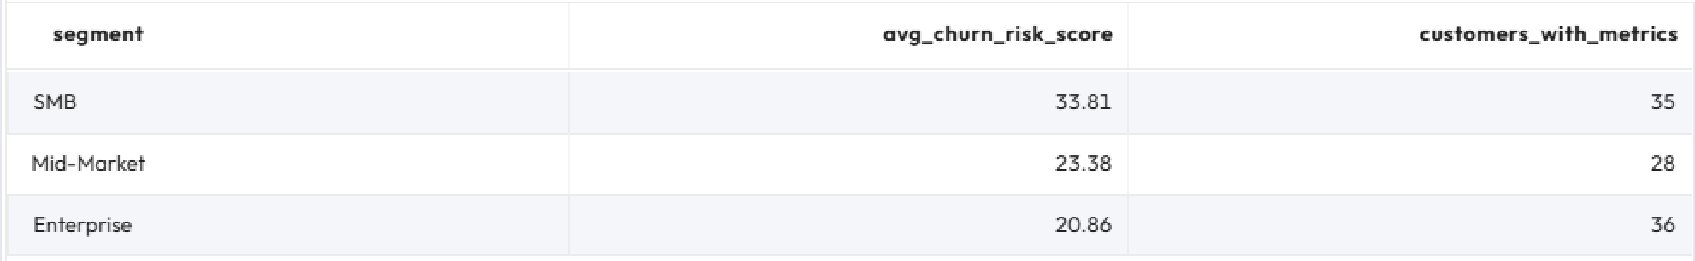

Step 5: Query a data product to answer a business question
- Let’s query the Customer 360 data product to answer the business question “Which segments show the highest churn risk?”

SELECT
segment,
AVG(churn_risk_score) AS avg_churn_risk_score,
COUNT(customer_id) AS customers_with_metrics
FROM hive.dataproducts.customer_360
GROUP BY segment
ORDER BY avg_churn_risk_score DESC;

✅The curated dataset makes answering the business question clear, fast, and reliable. You reach the same results but with much less effort.

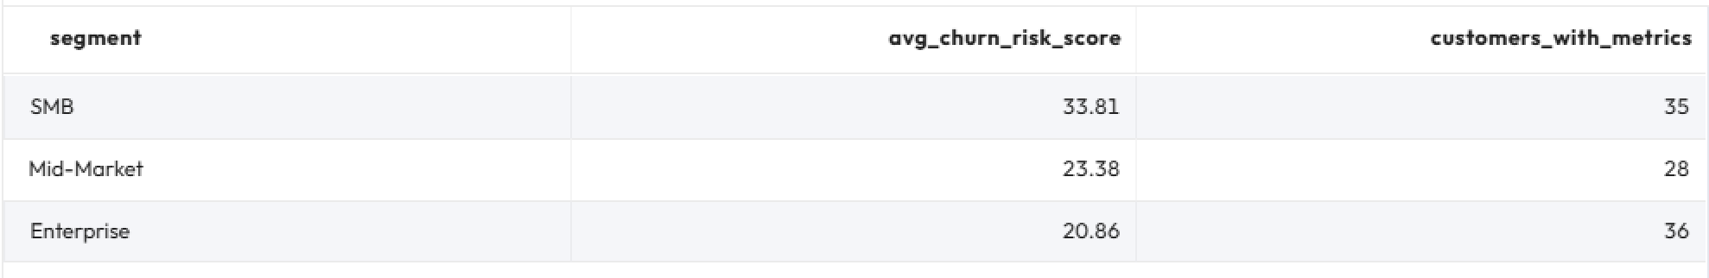

Summary
- Both methods (querying raw tables and data products) produce the same results.
- The raw approach requires a long, complex query.
- The curated approach requires just a few lines.
Key takeaway: Curated data products like Customer 360 enable analysts and business users to focus on insights rather than wrestling with raw schemas.

END OF LAB EXERCISE

